Manor Primary Phonics Overview

Phase | Summary | Sounds | Tricky words & HF words | When is it taught and by which year group? | Assessment
1 | This listening and speaking phase is taught across pre-school, nursery and continues in YR
2 | 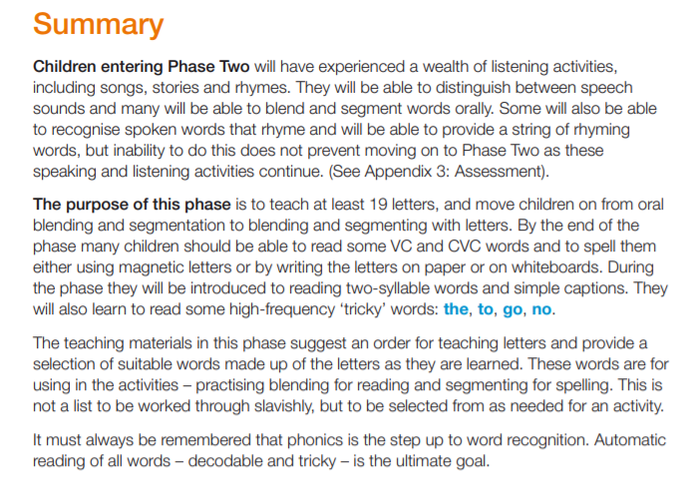 | S a t p i n m d g o c k ck e u r h b f/ff l/ll ss | I no go to the into  Is it an at (Hf) | Term 1 and 2  RECEPTION | 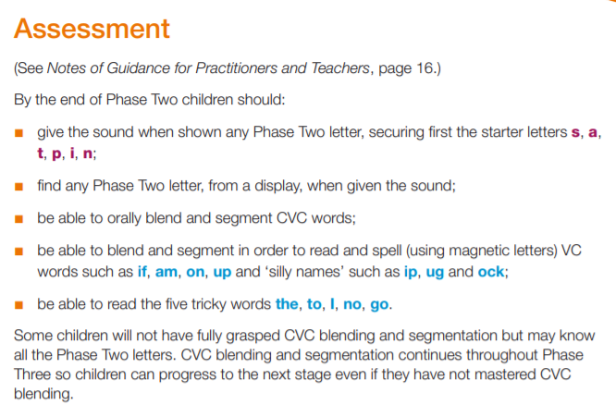
3 |  | J v w x y z/zz qu ch sh th ng ai ee igh oa oo ar or ur ow oi ear air ure er | He she we be me was my you they all are her | Term 3, 4 and 5  RECEPTION | 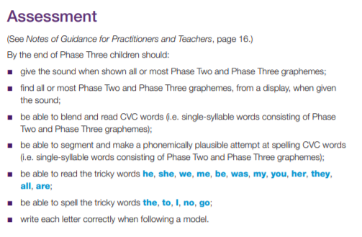
4 | 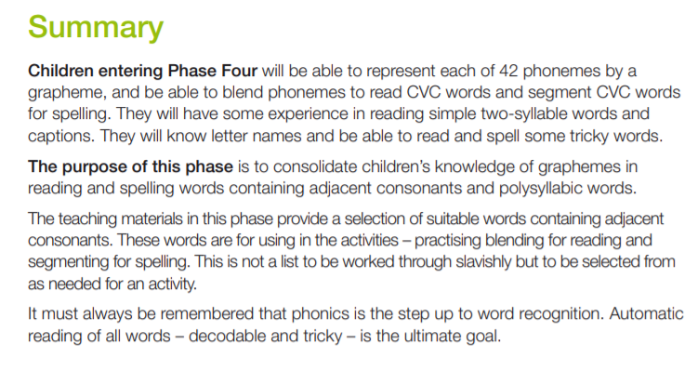 | No new sounds | Have  Like  Come  Some  Were  There  Little  One  Do when  Out  What  Said  so | Term 1 YEAR 1 | 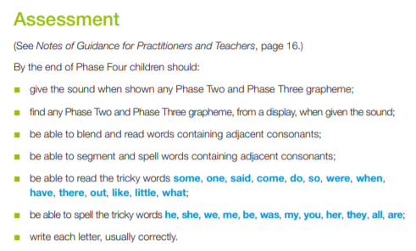
5 | 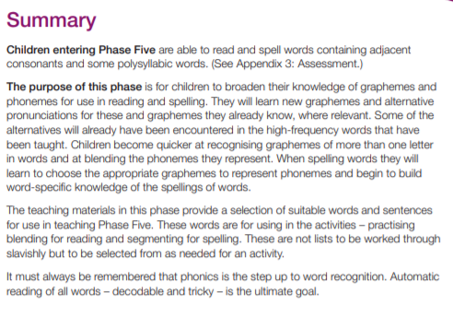 | ai ou  ie ea  oy ir  ue aw  wh ph  ew au  oe a-e  e-e i-e  o-eu-e  alt pron.  i o c g u ow ie ea er a y ch ou | Oh their people  Mr Mrs  Looked  Called  Asked  Water  Where  Who  Again  Thought  Through  Work  Mouse  Many  Laughed  Because  Different  Any  Eyes  Friend  Once  please | Term 2 to 6 YEAR 1  (Y1 covers past tense etc from NC spelling curriculum in summer terms) | 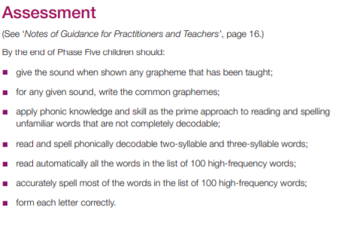
6 | 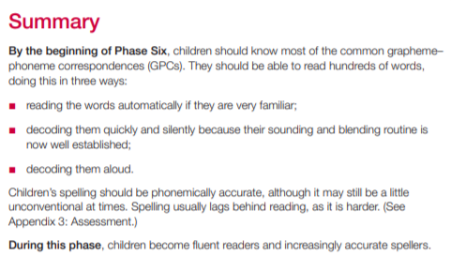 | Phase 5 recap  Spelling patterns for Y2 NC |  | Term 1 YEAR 2  Term 2 onwards  YEAR 2

Termly phonic overviews for YR, Y1, Y2
TERM | Reception | Year 1 | Year 2
1 | Phase 1:  - Sound games: instruments, music, song, different sounds, listen and respond activities to develop active listening skills  Phase 2:  Graphemes: s, a, t, p, i, n | Phase 3:  To recall & find any sound from a given grapheme.  To blend and segment CVC words.  To read tricky words for phase 3  To spell phase 2 words  Phase 4:  To blend and segment words with adjacent consonants.  - To read: some, one, said, come, do, so, were, when, have, there, out, like, little, what.  - To spell: they, was you, my, all, are, her, he, she, me, we, be | Recap phase 3 and 5 phonemes and tricky words
2 | Phase 2:  Orally segment CV/VC words  - Graphemes: i, n, m, d, g, o, c, k, ck, e, u, r, h, b  - To read: I to no go the into | Phase 5  Graphemes: ai, ou, ie, ea, oy, ir, ue, aw  wh, ph, ew, oe, au, ey, a-e, e-e, i-e, o-e,  To read and spell: Oh, their, people, Mr, Mrs, Looked, Called, Asked | National Curriculum p7-10
3 | Phase 2/3:  Blend and segment CVC words  - Graphemes: f, ff, l, ll, ss, j, v, w, x, y, z, zz, qu  - To spell: I, no, go, to, the, into  - To read: he, she, we, me, be, | Phase 5  Graphemes: u-e, i, o ,c, g, u, ow, ie, ea, er, a, y, ch, ou  To read and spell: Water, Where, Who, Again, Thought, Through
4 | Phase 3:  - Graphemes: Ch, sh, th, ng, ai, ee, igh, oa, or, ar, or, ur  - To spell: I, no, go, to, the, into  - To read: they, was you, my | Phase 5  Graphemes: i, o ,c, g, u, ow, ie, ea, er, a, y, ch, ou  To read and spell: Work, Mouse, Many, Laughed, Because
5 | Phase 3:  - Graphemes: ow, oi, ear, air, ure, er  - To read all, are, her  - To spell: he, she, we, me, be | Phase 5  Graphemes: 100 high frequency words  To read and spell: Work, Mouse, Many, Laughed, Because
6 | Recap, consolidation and polysyllabic words | Phase 5  Graphemes: spelling patterns NC (p 6 of National Curriculum spelling appendix)  To read and spell: Different, Any, Eyes, Friend, Once, please

